**ITC Hotels Revenue Analysis Report :**

**Data Cleaning & Transformation :**

The dataset underwent rigorous cleaning and transformation to ensure accuracy and usability:

1. **Revenue Realized & Cancellation Revenue:**
   * Calculated the percentage of revenue lost during cancellations by dividing the revenue_realized column by the revenue_generated column.
   * Assumed a 40%-60% split where 40% is retained by hotels and 60% is refunded.
2. **Ratings Adjustment:**
   * Filled null ratings where the booking_status was "checked out". For "cancelled" or "no-show" statuses, ratings were left null.
   * Created an average rating per property (property_id) using a grouped table.
   * Merged this data back with the original table to replace null values with the computed averages.
3. **Length of Stay Calculation:**
   * Added a custom column to compute the length of stay as checkedout_date - check_in_date, and transformed the result into days.
4. **Booking Lead Time:**
   * Created a custom column for lead time (check_in_date - booking_date) and transformed it into days.
5. **Calendar Table Creation:**
   * Created a calendar table with columns for months, weeks, day names, weekends, and holiday flags.
   * Established bidirectional relationships between the calendar table and the holidays table to ensure proper data flow for holiday-specific insights.
6. **Room Occupancy Adjustment:**
   * Adjusted successful_bookings to account for only "checked out" statuses from the bookings table to get actual room capacity data.

**Final Deliverable**

A comprehensive .pbix Power BI file showcasing these insights has been uploaded to GitHub.

Top of Form

**Insights & Analysis**

**Page 1: Financial Overview & Revenue Performance**

* **Revenue Distribution:**
  + ITC Exotica generated the highest revenue in the Luxury category, while ITC Palace excelled in the Business category.
  + Elite room class contributed the most to overall revenue.
* **Cumulative Revenue:**
  + Cumulative revenue trends were calculated using DAX to track revenue growth across the dataset's timeline.
* **Growth Analysis:**
  + **Month-over-Month (MoM) Growth:** Calculated using previous month's revenue as the base.
  + **Week-over-Week (WoW) Growth:** Addressed challenges with incomplete week data by using week_of_year filtering instead of date-based calculations.
* **KPIs:**
  + Average Daily Rate (ADR): ₹6.49K (calculated as room revenue divided by rooms sold).
  + Revenue Per Available Room (RevPAR): Derived by multiplying ADR with the occupancy rate.

**Page 2: Occupancy & Capacity Analysis**

* **Occupancy Rate:**
  + Calculated as (checked_out + no_show) / total_capacity, yielding an overall rate of 43.5%.
  + Weekend occupancy was higher (47%) compared to weekdays (42%).
* **Seasonal Trends:**
  + A strong positive correlation (0.45) between occupancy and revenue was identified.
  + RevPAR displayed a similar correlation with occupancy.
* **Insights:**
  + Properties with higher occupancy rates generally had better revenue performance.

**Page 3: Room Category Performance & Booking Insights**

* **Revenue by Room Class:**
  + Elite room class dominated revenue generation.
  + Bookings closer to the check-in date (2-3 days before) resulted in higher revenue.
* **KPIs:**
  + Average Length of Stay (ALOS): Calculated per property and room class.
  + Average Booking Lead Time: Highlighted shorter booking windows for better revenue.
* **Trend Analysis:**
  + Both MoM and WoW growth were calculated to track room class performance.

**Page 4: Cancellations & Lost Revenue Analysis**

* **Cancellation Rate:**
  + Cancellation rate = (Number of cancellations / total bookings).
  + Patterns revealed peak cancellations in June and July, particularly in specific room types.
* **Lost Revenue:**
  + Total revenue loss = SUM(revenue_generated) - SUM(revenue_realized).
* **Insights:**
  + June witnessed the highest cancellations due to possible seasonality or customer preferences.

**Conclusion & Recommendations :**

* ITC Hotels’ Elite room class and ITC Exotica’s Luxury category are the top-performing segments, warranting further investment and marketing efforts.
* High weekend occupancy rates suggest targeted campaigns during weekdays could drive additional revenue.
* Booking lead time and length of stay analyses indicate that shorter lead times correlate with higher revenue. Promoting last-minute deals could capitalize on this trend.
* High cancellations during peak months highlight the need for a flexible cancellation policy or incentives to reduce cancellation rates.

**Dashboard Screenshots :**

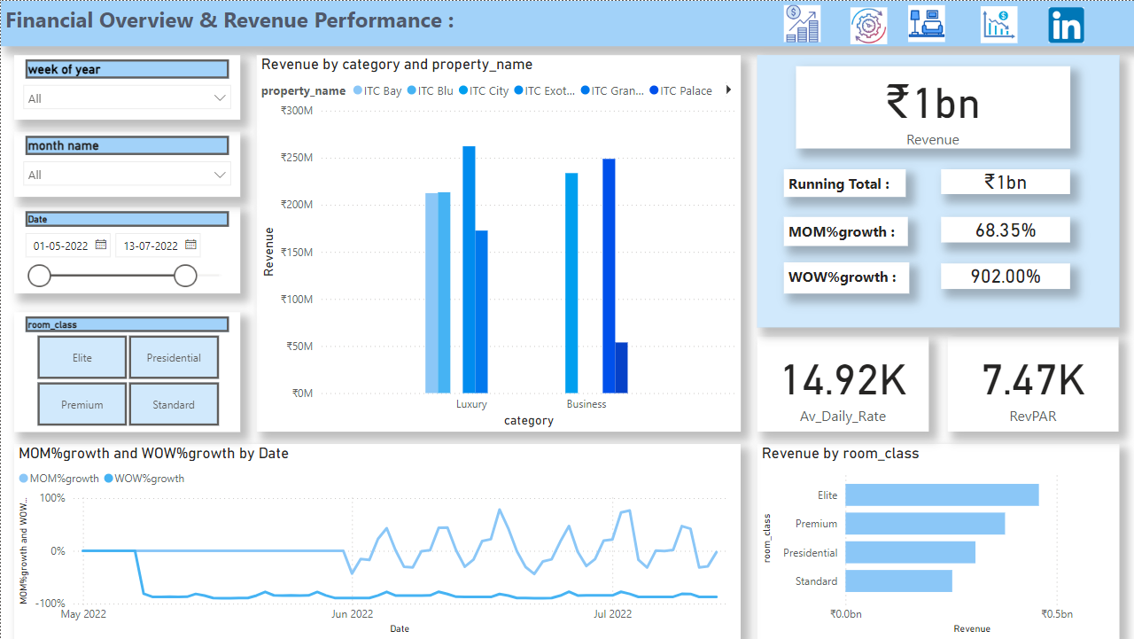

--------------------------------------------------------------------------------------------------------------------------------------

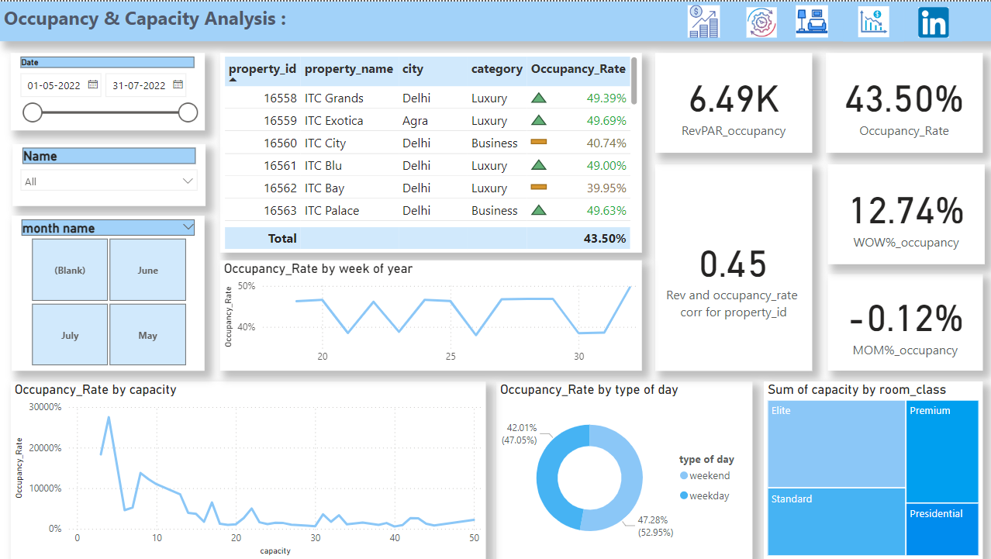

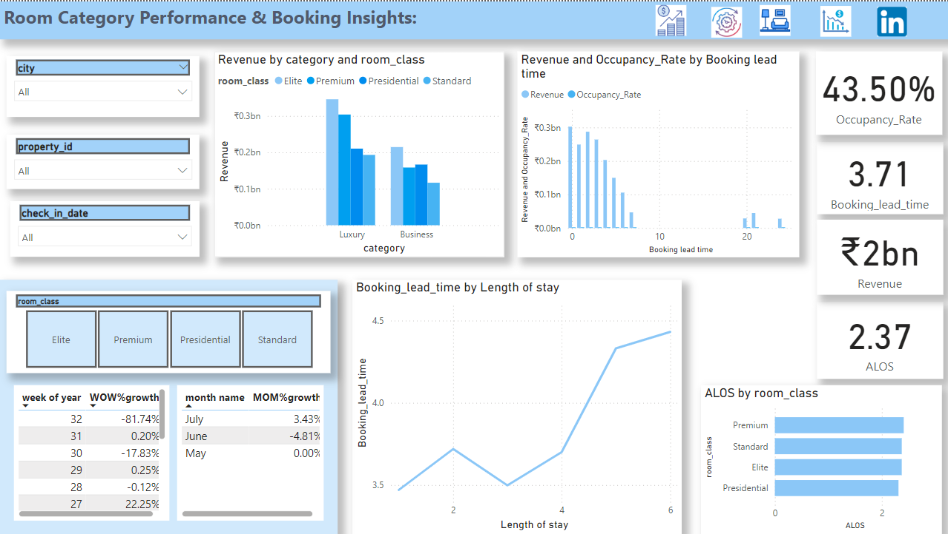

--------------------------------------------------------------------------------------------------------------------------------------

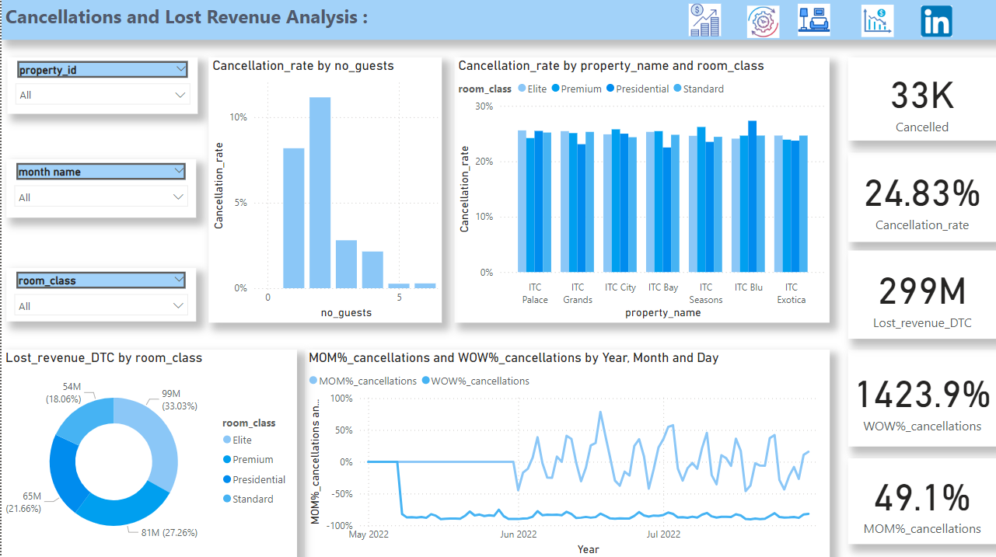Bottom of Form